**Tentative Dates, Coordinators list and Components list for IOT workshop Phase-I (Using NodeMCU)**

* **Dates**

1. From 24th to 28th of December
2. From 7th to 11th of January

* **Coordinators list**

|  |  |  |  |
| --- | --- | --- | --- |
| **Sl** | **Name** | **Branch** | **Reg.** |
| 1. | Pranab Kumar Mahanta | CTIS | 170301200033 |
| 2. | Kunal Panigrahi | CSE | 170301120127 |
| 3. | Aniket Senapati | CSE | 170301120105 |
| 4. | Subham Nayak | CSE | 180301120042 |
| 5. | Anand Kumar Tiwari | ECE | 180301130003 |
| 6. |  |  |  |

* **Components list**

1. **NodeMCU By Amica**

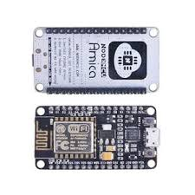

1. **Bread Board**

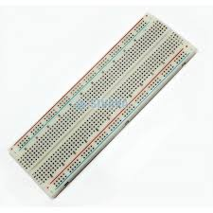

1. **Connecting Wires**

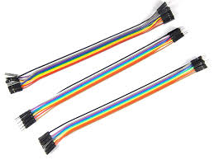

1. **Bread board power supply (MB102)**

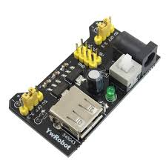

1. **Power Supply to MB102 via**

A.USB A to USB A type

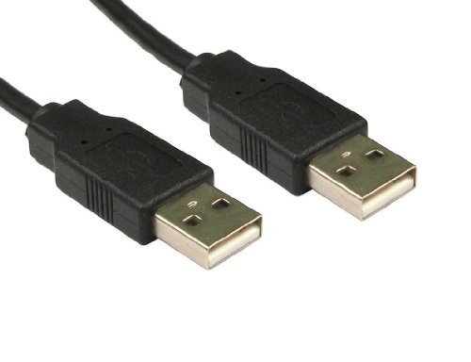

**OR**

B.Power Adapter

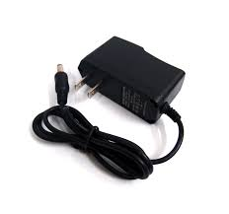

1. **LEDs**

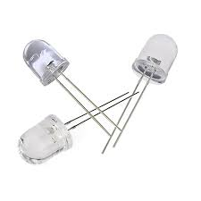

1. **LDR and a resister**

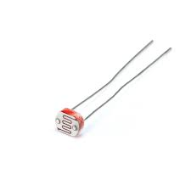

1. **Buzzer**

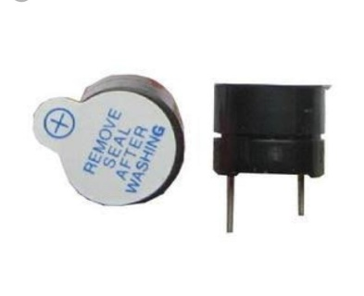

1. **Motor Driver**

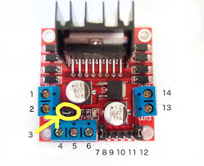

1. **Low power DC motor**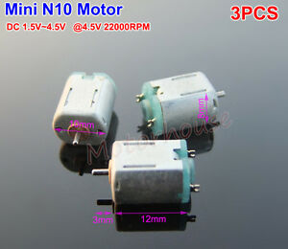
2. **Servo Motor(SG90)**

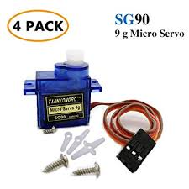

1. **Ultrasonic Sensor(HC-SR04)**

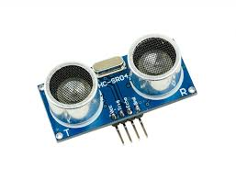

1. **Temperature humidity sensor(DHT11)**

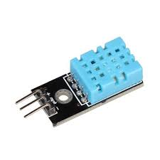

**New sensors**

1. **Smoke and combustible gas sensor(MQ2)**

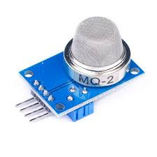

1. **Motion sensor module vibration detector(SW-420)**

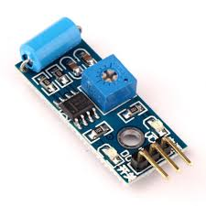

1. **Pyroelectric Infrared Sensor (HC-SR501)**

